Concur Expense System
Frequently Asked Questions (All Domestic US CL Employees including Gale)

- Why aren’t my American Express transactions showing up in the Concur Expense System?
If you know for sure you have some American Express transactions that should be appearing in the new Concur Expense System, and you have given them adequate time to clear, you need to send an email to ms.te@cengage.com and let them know. They will check the situation out for you and get back to you via email.
- Why can’t I report company or personal car mileage?
Users must first register their personal car in the Concur Expense System. This can be done on the Profile tab. If you don’t register your personal car, you will not be able to report Personal Car Mileage.
Effective July 1, 2010, company car mileage will no longer be entered into the Concur Expense System. Company car mileage must be entered into the Donlen system only.
- I don’t like all the email notifications I am receiving from the new system. How do I turn some of them off?
On the Profile tab, Expense Preferences screen, you can define when you receive email notifications. By default, all the options under Send email when are selected. Simply clear the check box for the emails you do not want to receive. When finished, make sure you click the Save button before exiting the Expense Preferences screen.
- How can I verify that my American Express card has been paid, what my balance due is, etc.?
- Sign up for online statements at http://www.americanexpress.com/checkyourbill
- On the left side of the screen, in the Log In area, click the Register here link

Make sure you sign up for the following email alerts:

- Click the link above … and log in
- On the right side of the screen, under Manage Your Account … click the Update Email Settings and Account Alerts link
- Make sure you select the following alerts:
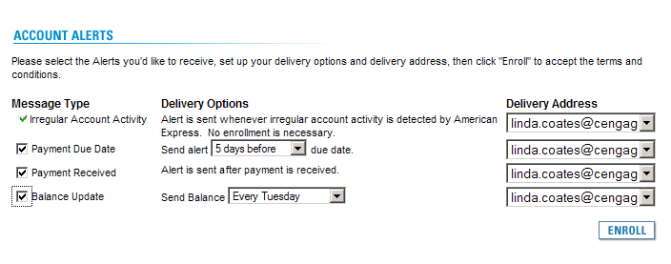
- Why isn’t Cengage paying my full American Express statement?
As we did while using Extensity, Cengage is only paying business related charges. You are responsible for paying any personal charges to American Express directly. Please remember it is a violation of company policy to use your American Express for personal use.
- How do I enroll in the Concur Expense System?
The CLMS T&E Department is responsible for all new T&E setup for Cengage Learning (including CL Gale). Please go to the Cengage Learning intranet site “Inside” and download and complete the CONCUR ExpenseLink Enrollment form and send to the T&E Department at ms.te@cengage.com.
- How do I sign onto the Concur Expense System? What if I forget my Password?
Go to the Concur Expense System website - https://www.concursolutions.com/. Be sure to add this link to your Web browser Favorites / Bookmarks.
- User Name: field, enter your PeopleSoft User ID @cengage …for example, 5200539@cengage
- Password: Initial password … welcome (all lower case)
- Click the Login button or press Enter on your keyboard

The first time you login using welcome as your password, Concur will prompt you to change the password.

Old Password: welcome
New Password: Enter a new password
Re-enter New Password: Re-enter your new password
Password Hint: Enter your new password in this field also

Passwords are case-sensitive … must be at least six (6) characters and can contain numbers (0-9), upper and lower case characters, symbols such as %*@ and #, and cannot contain spaces.

If you forget your password, you can click the Forgot your password? link on the login screen, and select one of the following options:

- Send me an email with my password hint
- Send me an email with a link to reset my password

- What do I do if I can’t find a charge in either ExpenseLink or the new Concur Expense System?
First, contact ms.te@cengage.com. We may be able to find the charge and bring it into the new Concur Expense System. If we cannot, reflect the charge as a cash item and pay American Express directly.
- Do I still have to FAX my receipts?
You can still FAX your receipts if that’s your preference. Or, users can now scan their receipts and attach them directly to their expense report.
- How do I save my expense report so I don’t lose all my work?
Every time you save an individual expense item, the system saves your entire expense report.
- Where do I input mileage (both Personal and Company Car)?
Personal cars (used for company business travel) have to be registered in the new Concur Expense System. To register a car, click the Profile tab, and then click Personal Car on the left side of the screen under Expense Settings.

Effective July 1, 2010, company car mileage will no longer be entered into the Concur Expense System. Company car mileage must be entered into the Donlen system only.
- How often should I do an expense report?
It is recommended you submit one expense report per week.
- What if I don’t see my Amex Credit Card transactions in the new Concur Expense System?
Send an email immediately to ms.te@cengage.com and notify them.
- What training is available to me?
All training and documentation information is located on the CLMS T&E Inside site at http://inside/sites/ms/TE/Concur%20Expense%20System%20DocumentationTraining/Forms/AllItems.aspx
Live WebEx Session:
To schedule a live WebEx session, contact Linda Coates … linda.coates@cengage.com.

Recorded WebEx Session:
Click here to access the Concur Expense system recorded Webex session.

User Documentation:

Click here to access the Concur Expense System User Reference Guide.
- How will I be notified that my expense report has been paid by the Concur Expense System?
You will receive a system generated e-mail message.

- How do I apply for an AMEX card?
All employees who spend more than $1,000 per year (or the local equivalent) on travel expenses must apply for and use a corporate AMEX card to pay for those expenses. If you do not currently have an AMEX card, please contact:

- CL Gale - Marietta Jones Marietta.Jones@cengage.com
- Rest of domestic US Cengage Learning - Linda Tope Linda.Tope@Cengage.com

- How can I find out when my online statement is available?
Visit www.americanexpress.com to sign up for e-mail notification. Log in to your account. Under the Account Services section to the right, click Get Online-Only Statement and follow the steps to get the e-mail notification. You can also choose to continue to receive a paper statement.

- What are the AMEX penalties if I submit my expense report late?
Late Submission Penalties if Late After:
- 45 Days - Late fee
- 60 Days - Late fee
- 90 Days - Card suspended - Can no longer use AMEX card
- 120 Days - Card cancelled
- 180 Days - Information submitted to collection - Late payment information reported to credit bureaus

